How to calculate stock moving average in excel

Moving average in the [stock market](https://spreadcheaters.com/how-to-import-stock-prices-into-excel/), known as a simple moving average (SMA), involves calculating the mean of a specific set of values within a designated timeframe. This method adds up the numbers or closing stock prices and divides the sum by the count of values in the set. It provides a smoothed average that helps identify trends and fluctuations in stock prices over time.

The provided data represents the stock market performance over a span of ten days. It includes the opening and closing prices, as well as the highest and lowest prices reached during each day. The volume column indicates the number of shares traded. The RSI (Relative Strength Index) and Stochastic Oscillator offer insights into the stock's momentum and overbought/oversold conditions, respectively. The Bollinger Bands show the range within which the stock's price fluctuated, with the upper and lower limits indicated. In this tutorial, we will learn how to calculate moving average by using this data.

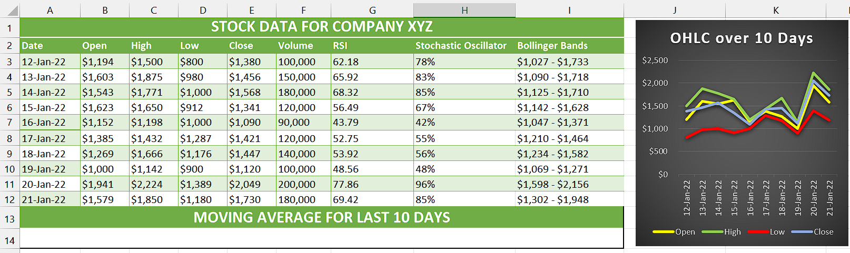

## Understanding the Function and its syntax

The AVERAGE function is a mathematical function commonly used in spreadsheet software, including Excel, to calculate the average value of a set of numbers. It is also applicable for calculating the moving average of a series of data points.

The syntax of the AVERAGE function is as follows:

=AVERAGE(number1, [number2], ...)

In this syntax, "number1", "number2", and so on represent the numerical values or cell references that you want to include in the average calculation. You can include multiple numbers or cell references by separating them with commas.

When calculating the moving average, you can provide a range of values or cell references representing a specific time period, such as a series of closing prices over a set number of days. The AVERAGE function will then sum up these values and divide the total by the number of data points, providing the average value for that period.

## Step 1 – Selecting the cell

* Select any empty cell where you want to calculate simple moving average.
* In this cell, we will apply the AVERAGE function to calculate simple moving average.



## Step 2 – Write the formula and implement it

* In the selected cell, type = (equal sign).
* Then, write AVERAGE and select AVERAGE Function by using Tab Button.
* Next, choose the group of cells that encompasses the closing prices of the most recent 10 days (or any desired number of days) for which you wish to compute the moving average.
* Then, close the parenthesis and your formula would look like this.

=AVERAGE(E3:E12)

* Now, press Enter and the moving average will be calculated.



## Explanation of Formula used in Step 2

In Step 2, the formula utilizes the AVERAGE function to calculate the moving average by summing up all the closing price data within a specified time period and then dividing the total by the number of days. Since there is only one closing price per day, the number of closing prices corresponds to the number of days, making it suitable to use the AVERAGE function for this calculation.